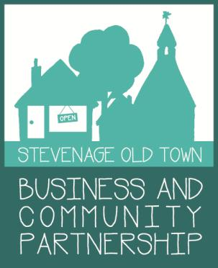
Stevenage Old Town Business
and Community Partnership Membership Form

In order to keep the many successes of the SOTBCP going we need all those in the local business community & community groups to pay an annual membership fee to help fund future events.

Membership Benefits:
− Participation in High street events
− Ability to have your say at the monthly meetings
− Receive news, minutes and updates on SOTBCP events by email
− Networking benefits by becoming part of the only group that represents Business & Community on our High Street
- Preferential rates on adverting in the Comet’s Old Town pages
- Discounted social media management fees with Spitfire PR
- Inclusion on the Old Town map to be circulated in local hotels and tourist attractions (enhanced members only)

Membership 2018

Membership fee Business
1-3 Employees £15 4-9 Employees £25 10+ Employees £35

Community group £10

Individual Resident £5

Enhanced membership an additional £25 pa

Business/ Community group: Name:

Address:

Telephone no:

Email:

Your business profile (maximum 100 words) *

( * for use in SOTBCP promotion and publicity material, unless you state otherwise)
Cheque's to SOTBCP: drop to Alta Image, Middle Row
OR Bank Transfer/Standing Order to account: 39119653
Sort code: 60-20-26 NatWest Payee ref: SOTBCP membership
Tick if receipt required

